**VIVA-2**

Name- Ravish Dagar

Sap-500061767

Roll No-96

BLENDER

* Aim- Design a Skyscraper on blender.
* Procedure-

1. Add a new mesh cube.
2. Shape it like a “mirror” and add array modifier on the y-axis.
3. Color the mirror with blue.
4. Now add duplicate of the whole section and join the two on x-y axis.
5. Now again make duplicate of the whole section and join the both section along the axis.
6. Now add array modifier along the z-axis, with 44 floors.

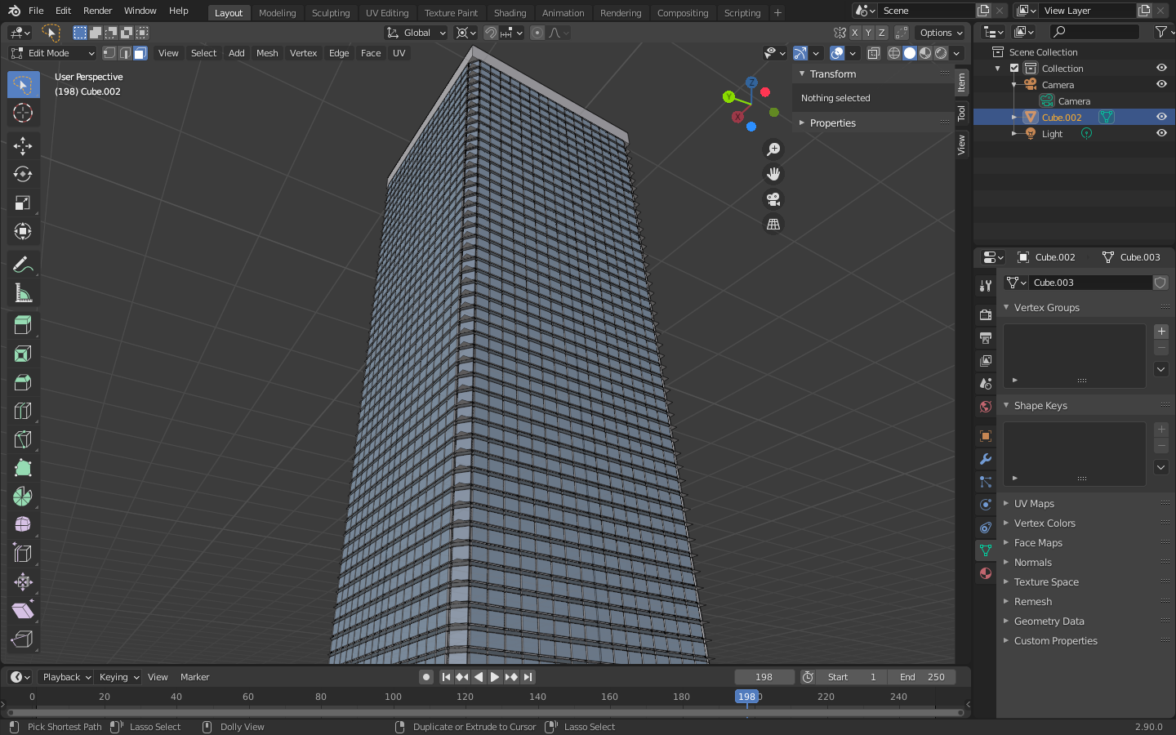

1. Now shape the top of the skyscraper accordingly.

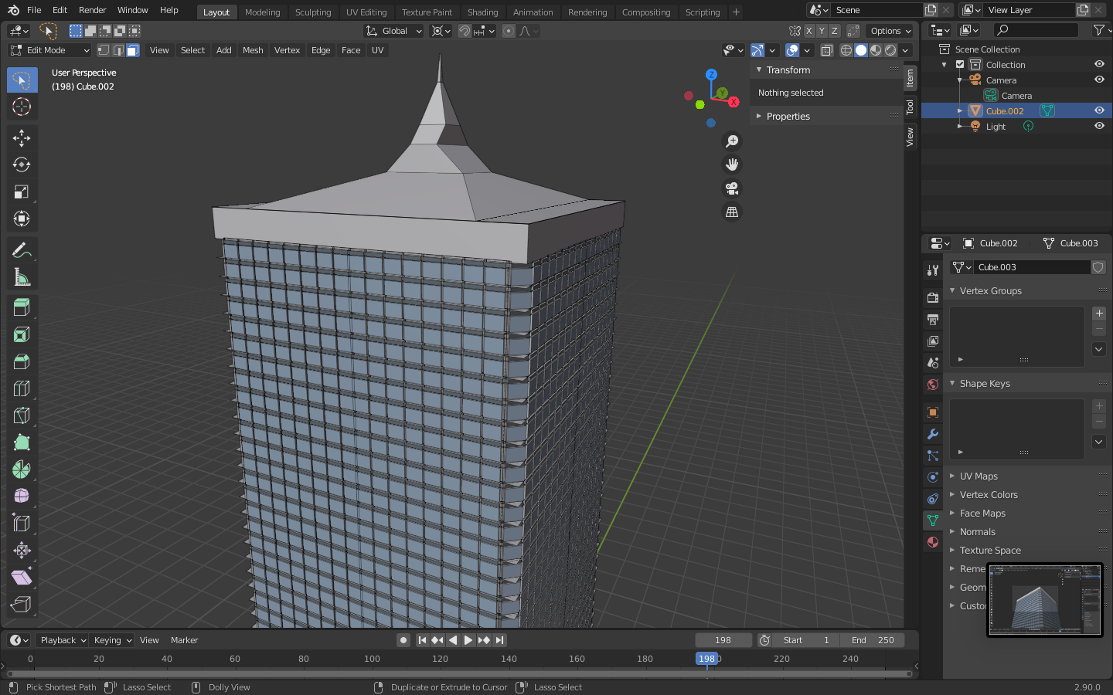

1. Hence, skyscraper is completed.

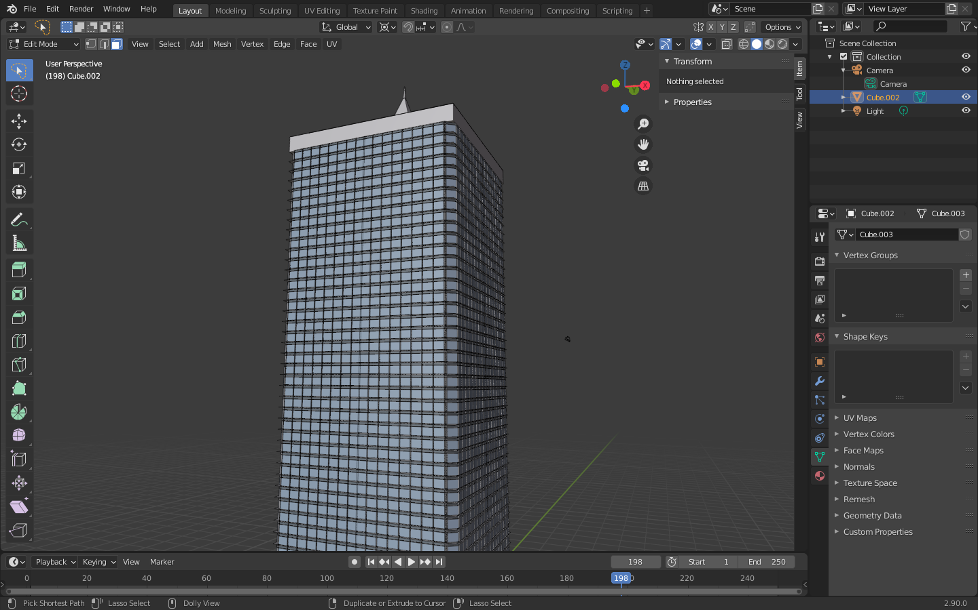

GIMP

* AIM-Design a mountain landscape in gimp.
* Procedure-

1. Open a new gimp file.
2. Color the background with sky blue.
3. Now design the shape of the mountain using brush (brown color)
4. Design the whole mountain and color the white on top of the mountain.
5. Now draw a sun with yellow color between the mountains.
6. Also, draw some birds in the blue sky using black thin brush.
7. Hence, the mountain landscape is completed.

